HOGASHOP API (Pro Plan)
- Click grant access to generate authorization code.
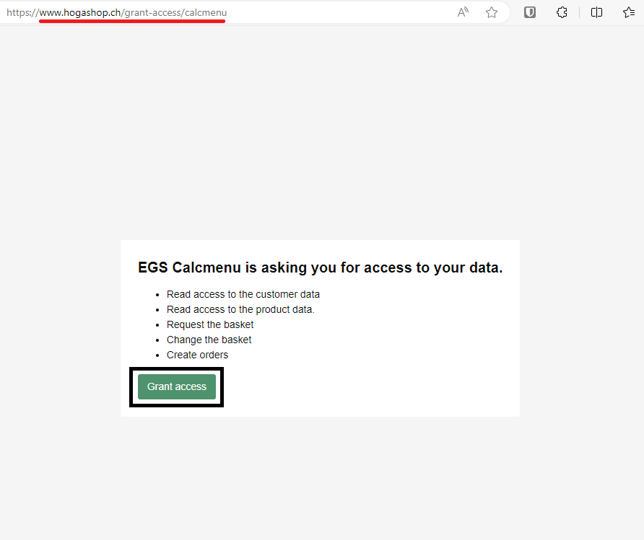
- Get the authorization code.
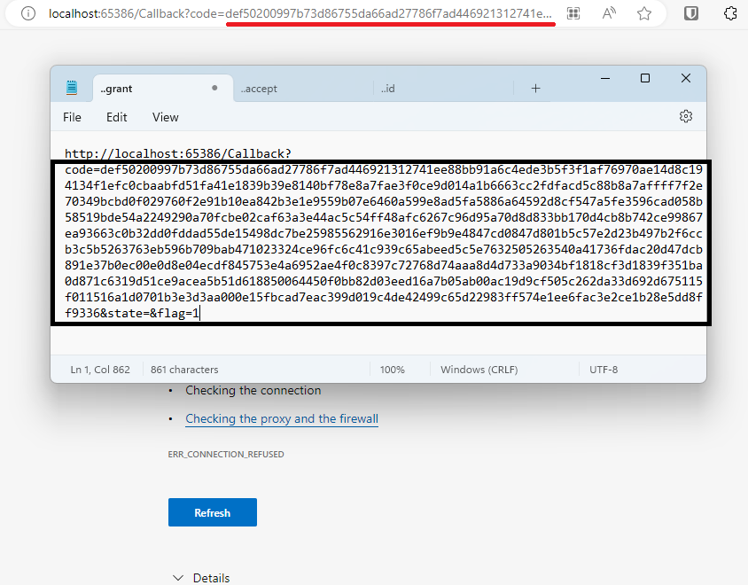
- Supply the necessary values and put the authorization code in the code field.
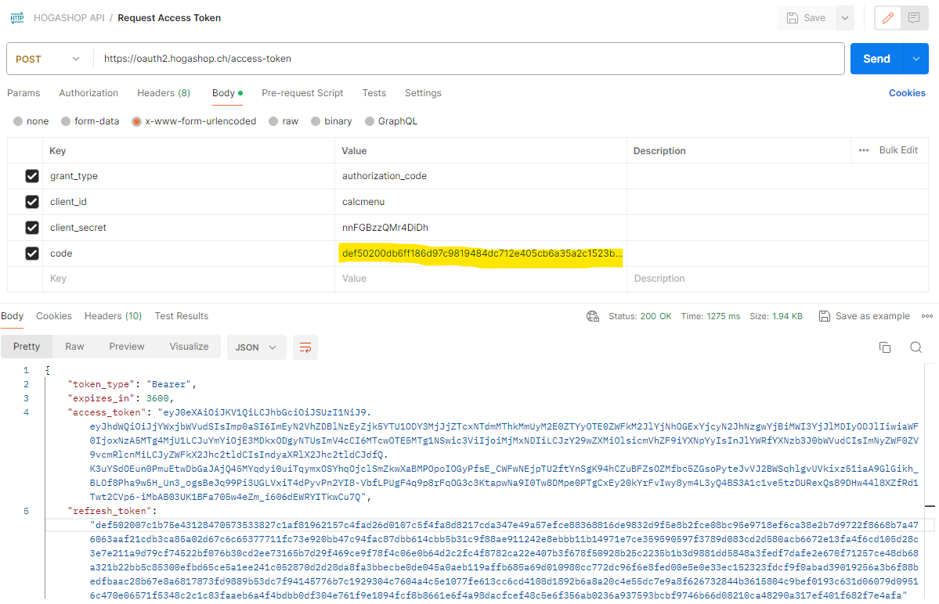

- Get the access token.
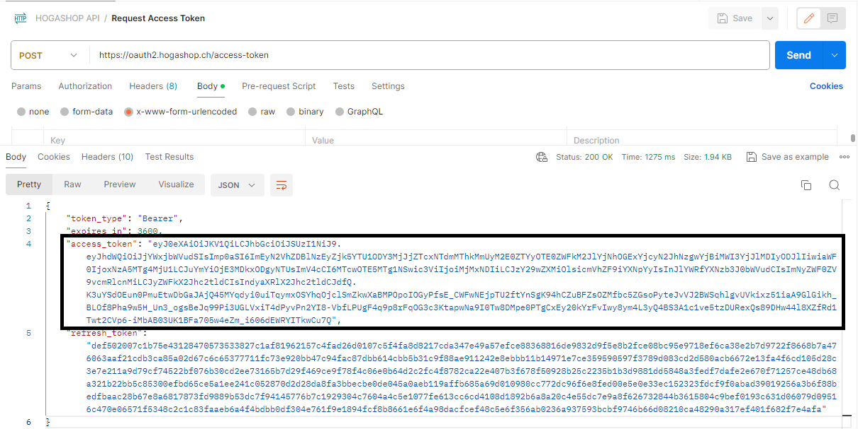
- Supply the access token in the authorization through the Bearer Token
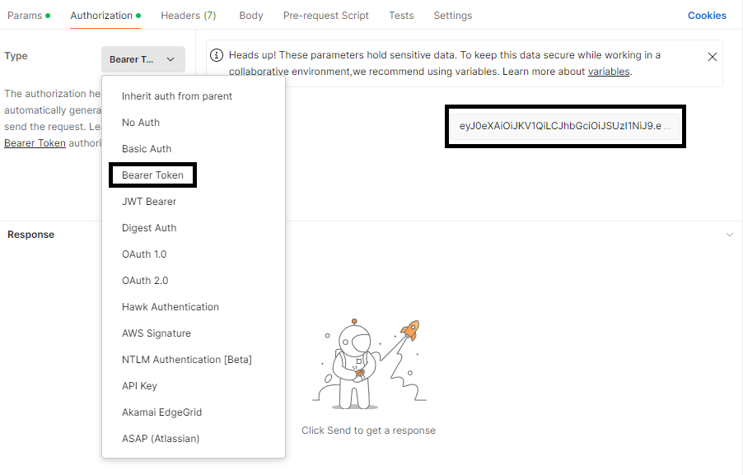
- Returns the list of available departments for the logged in user using GET method.
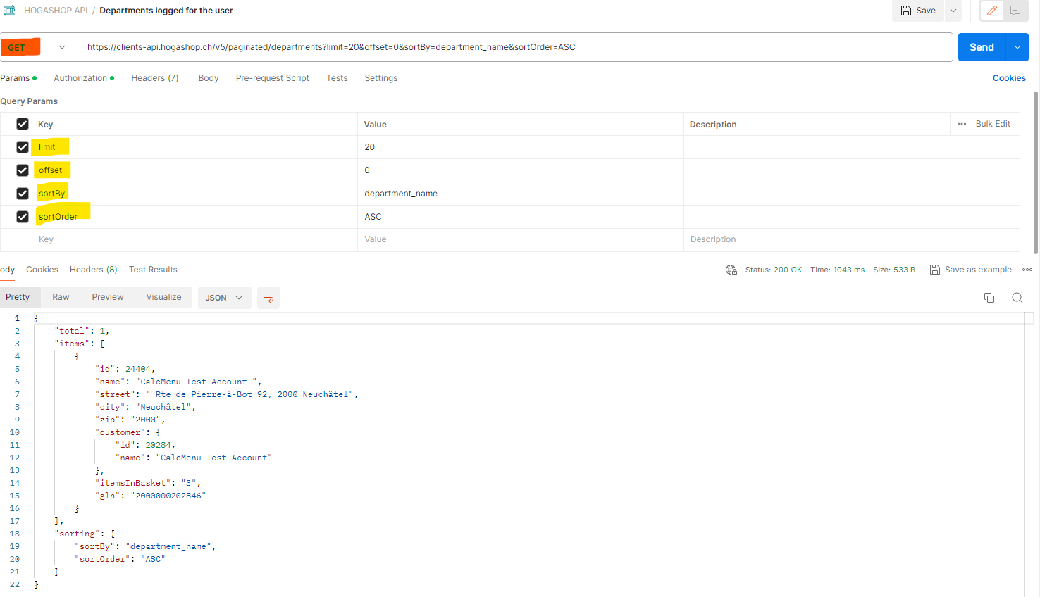

- Retrieves list of available products for a department currently on order lists using GET method. Supply the department ID.
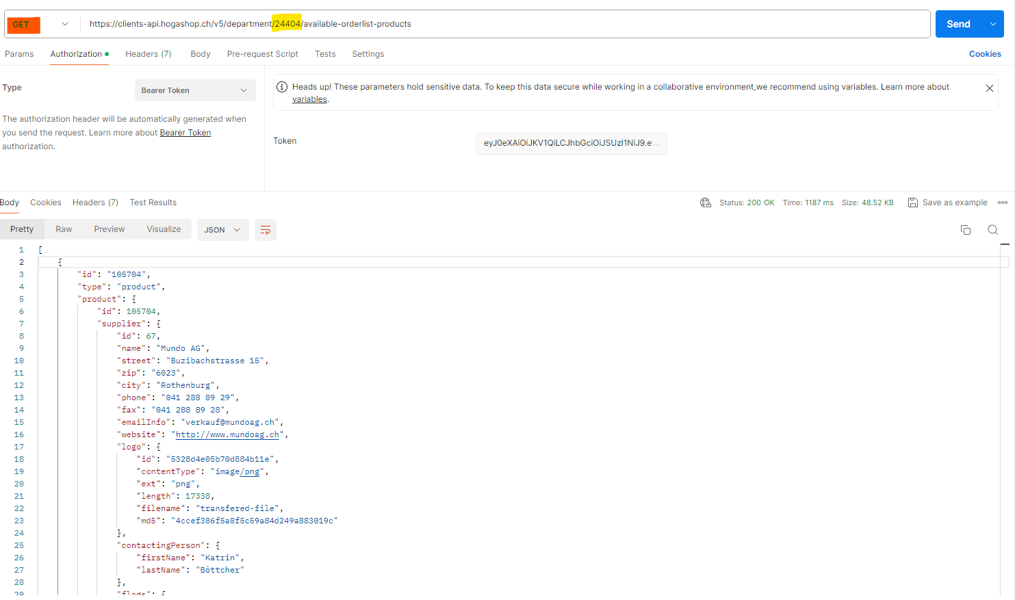
- Take note of the product IDs of the available products for these will be used in the later procedures.
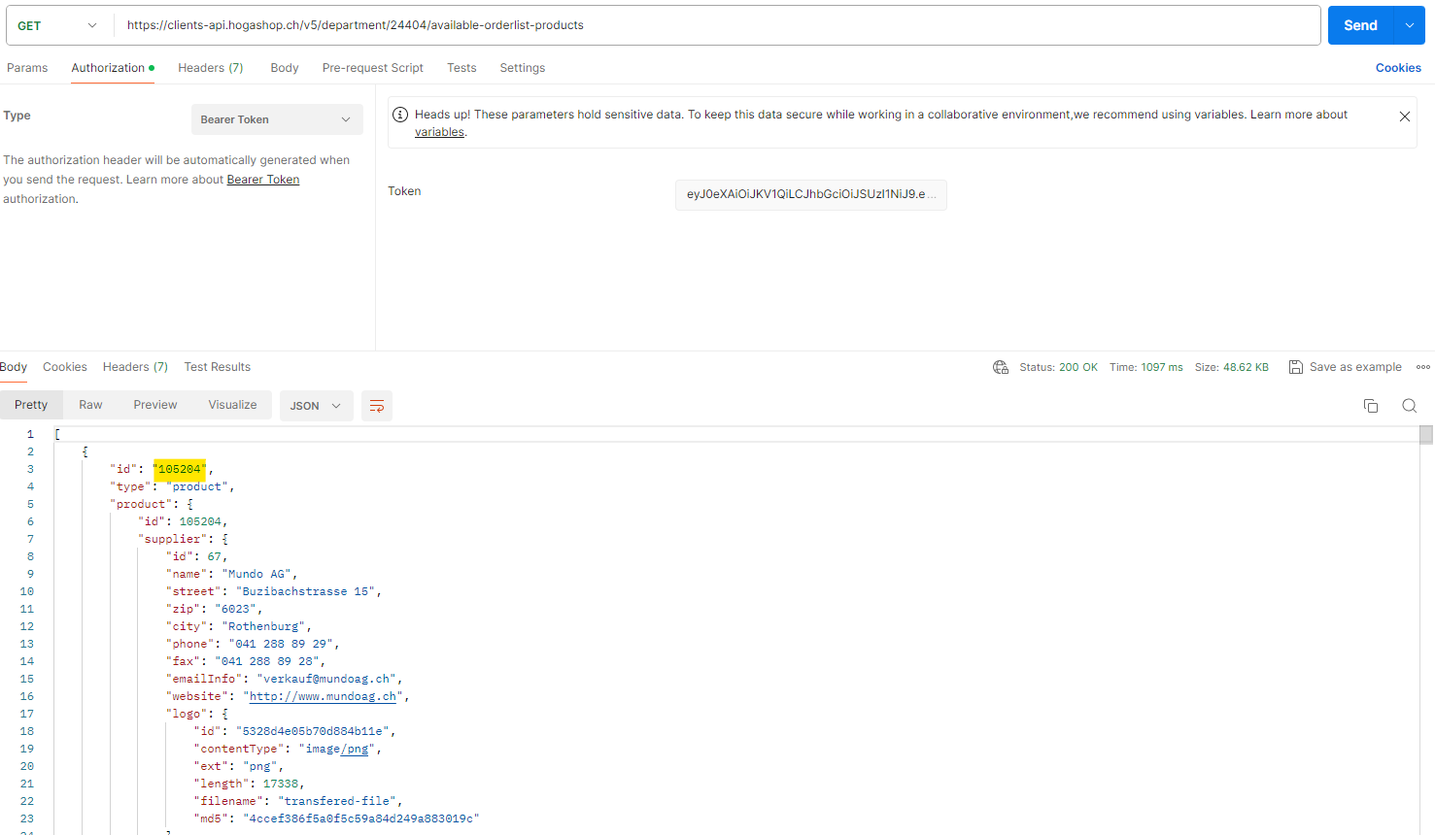

- Retrieves number of available products for a department currently on order lists using GET method. Supply the department ID.
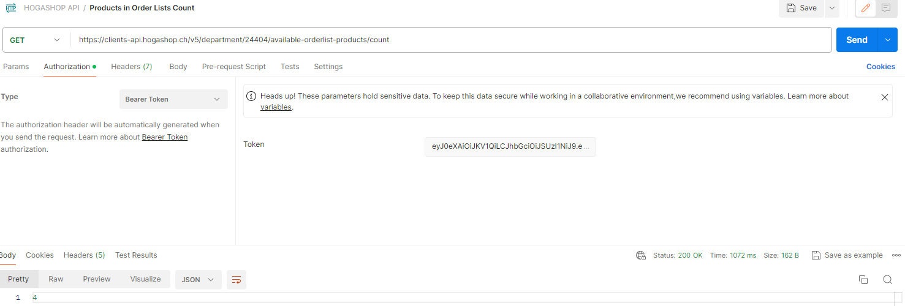
- Read the contents of the basket using GET method. Supply the department ID.
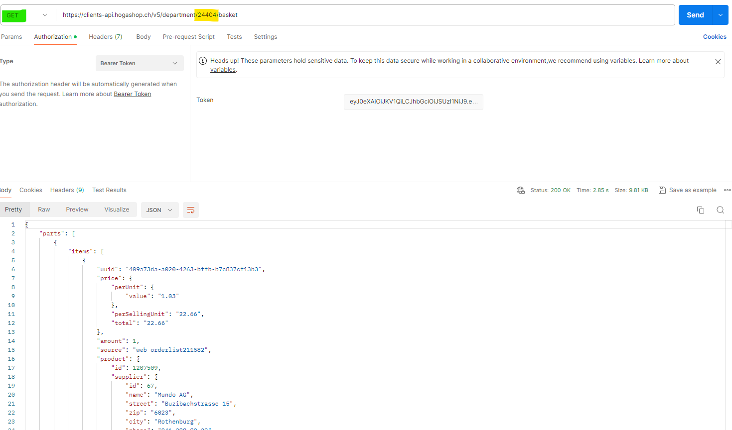
- Get the basket revision in the header result of the basket reader.
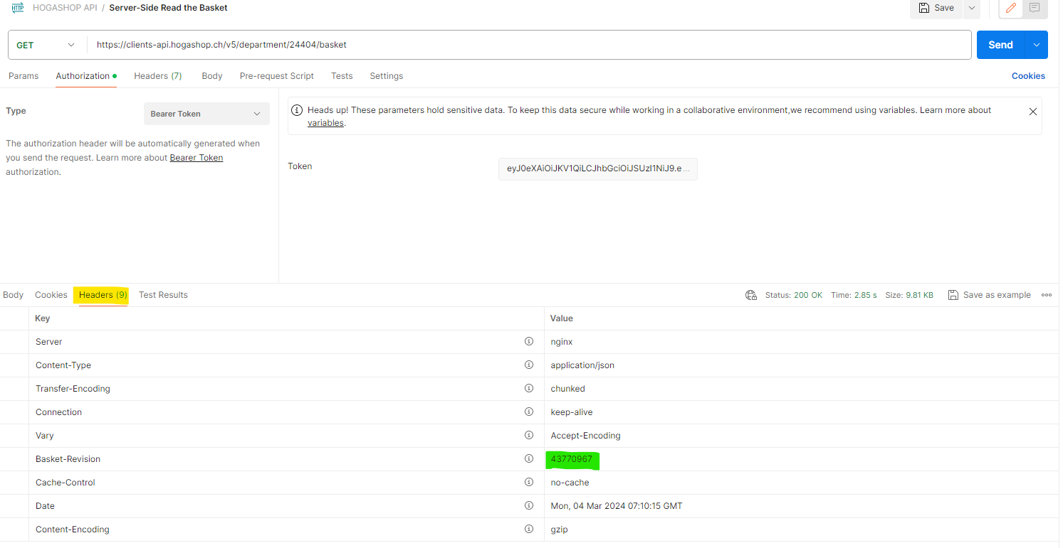

- Delete a basket using DELETE method. Supply the department ID and basket revision.
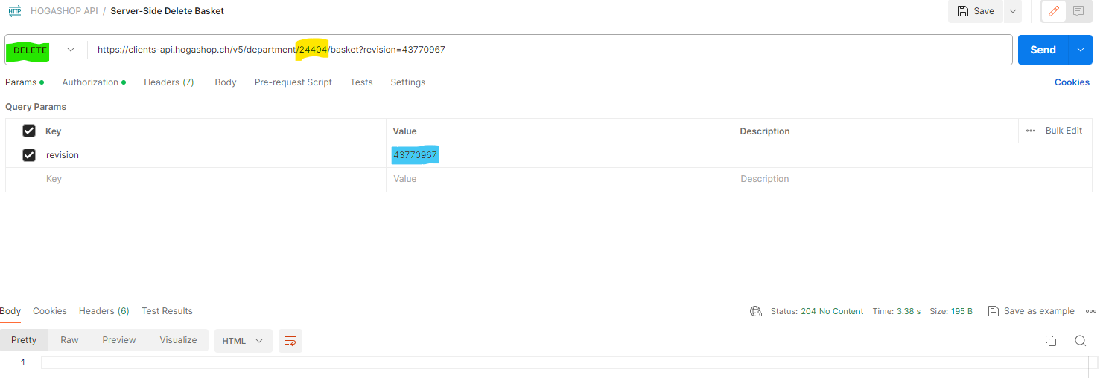

- Read a basket for a department and return it without items using GET method. Supply the department ID.
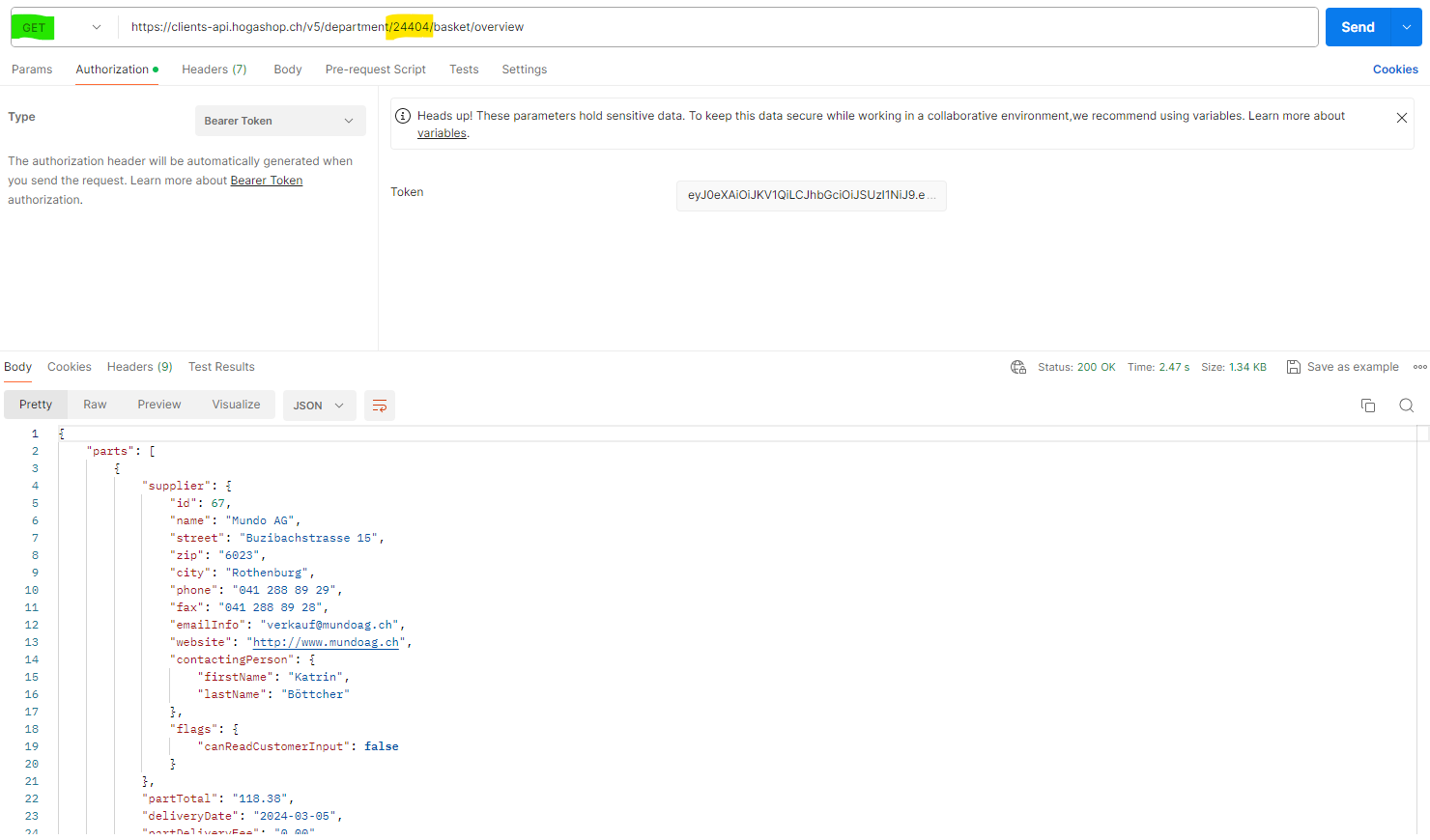
- Add items to basket using POST method. Supply the department ID. Supply the body with product id or product id and the amount of product to increase the quantity of the product. After this the client should GET the whole basket to obtain correct parts and totals.
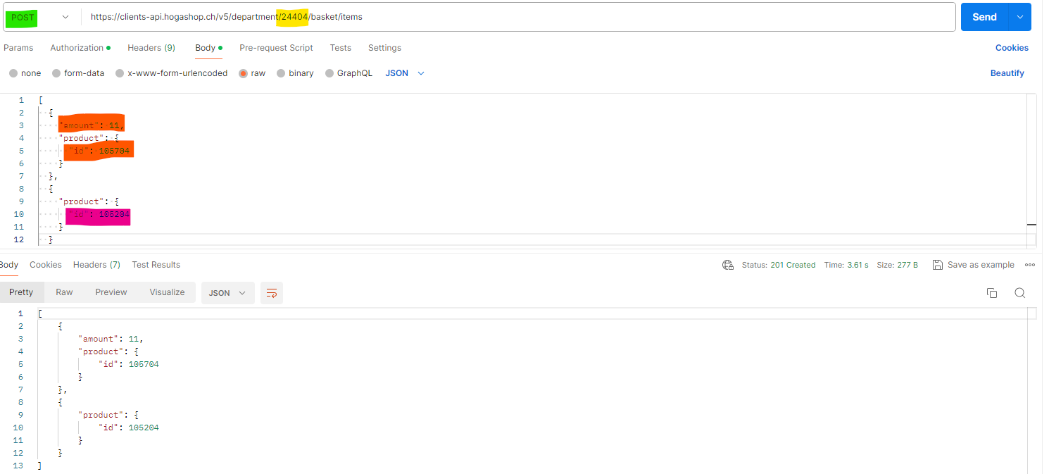

- Update an item using PUT method. Supply the parameter with department ID, basket part (starts at zero), basket item (starts at zero) and the basket revision. Supply the body with the product ID, quantity of the product (amount), and/or delivery date. After this the client should GET the whole basket to obtain correct/ latest basket revision.
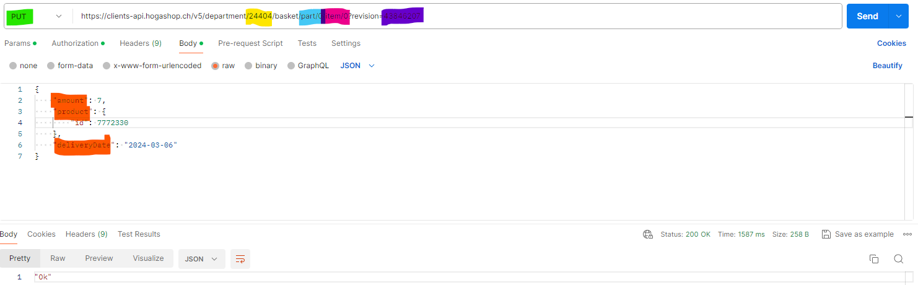
- Delete an item using DELETE method. Supply the parameter with department ID, basket part (starts at zero), basket item (starts at zero) and the basket revision. After this the client should GET the whole basket to obtain correct/ latest basket revision.
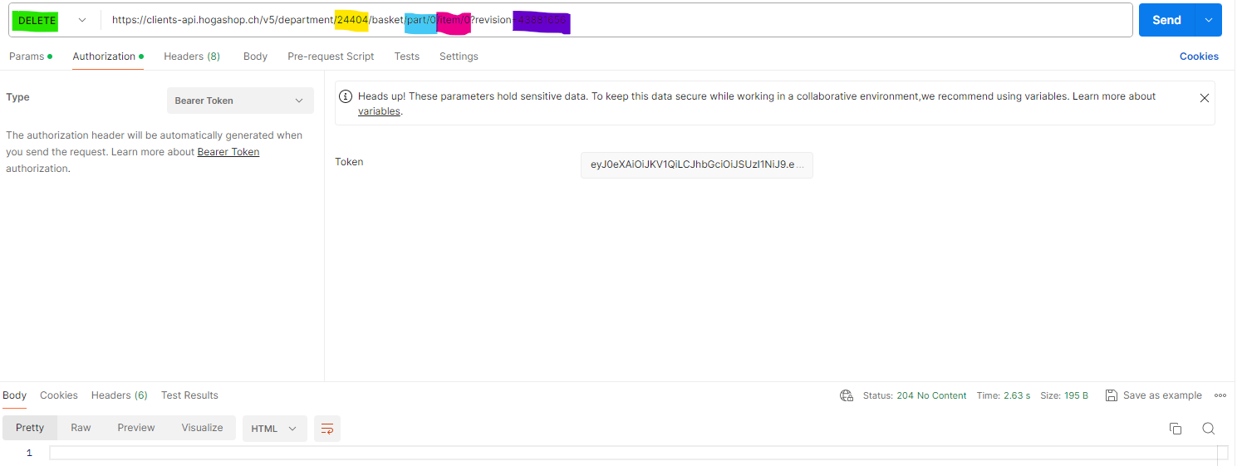
- Change the delivery date for a whole basket part or/and a comment for basket part using PUT method. Supply the parameter with department ID, part index, basket revision, delivery date, comment, and reference number. This process is getting an error message since we have set the Customer Input to ‘False’.
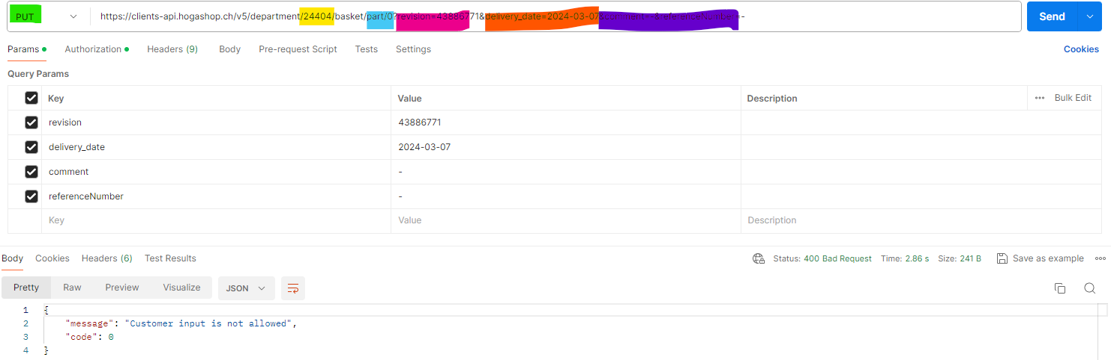
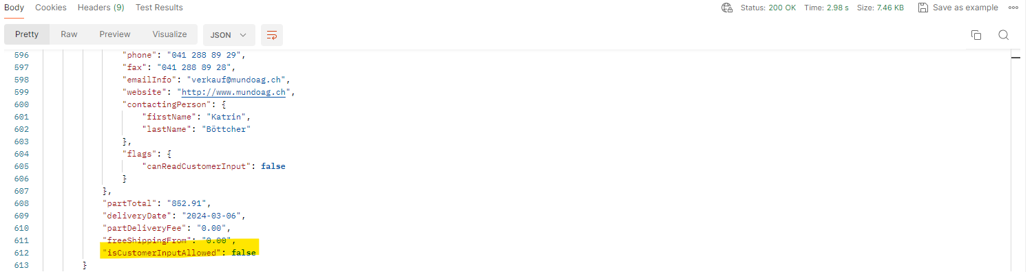
- Create an order using the basket stored at the server using POST method. Supply the department ID and the basket revision. This is the most suitable ordering method out of the two since the Plan we have availed is the Pro Plan. This process is getting an error message since the account given is for demo purpose only.
